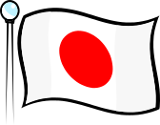

Open your hearts and your homes to a student from Japan
Host a Japanese Exchange Student!
May 25 – May 28, 2018 (3 Nights)
Kellogg PTSA invites you to
Host families are needed for approximately 30 Japanese middle school students who will be visiting Kellogg Middle School
Experience another culture without leaving home!
Program Overview
- All 8th graders from Shukutoku Sugamo Junior High School in Tokyo (100 students) visit Seattle for their annual school trip. Three local schools are host schools to welcome the students.
- Sugamo JHS students arrive 5/23 (Wed) and sightsee in Seattle and stay at a hotel. On Friday, 5/25, the students go to their host school for activities with Kellogg students and to meet host families. Host families and students enjoy the weekend together and students are dropped off on Monday morning at school.
- This is a double placement program (2 students per family)
Host Families Provide
- A warm and supportive atmosphere – like part of the family
- Room and board (NOTE: Students can share a room with a host sibling of the same gender, but must have a separate bed)
- Transportation – pick up students on Friday and drop them off on Monday
Host Families Receive
- The opportunity to make lasting friendships and learn about another culture.
- An international experience - without ever leaving home
- The chance to make a difference in an exchange student’s life
- Comprehensive support and assistance from program coordinators throughout the program.
- $20 per student, per night to help offset the costs of hosting. This stipend can also be donated to the school PTSA

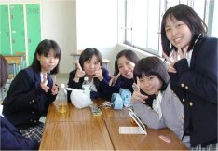


For more information
about hosting or to get an
application form, please contact:
Kellogg M.S. PTSA
Mary Ann Higgins
higmac2@gmail
Tanya Schoen
tanya_mae@hotmail.com
or

Mai Reed
seattle.edu@educationtourcenter.com
(206) 623-7060

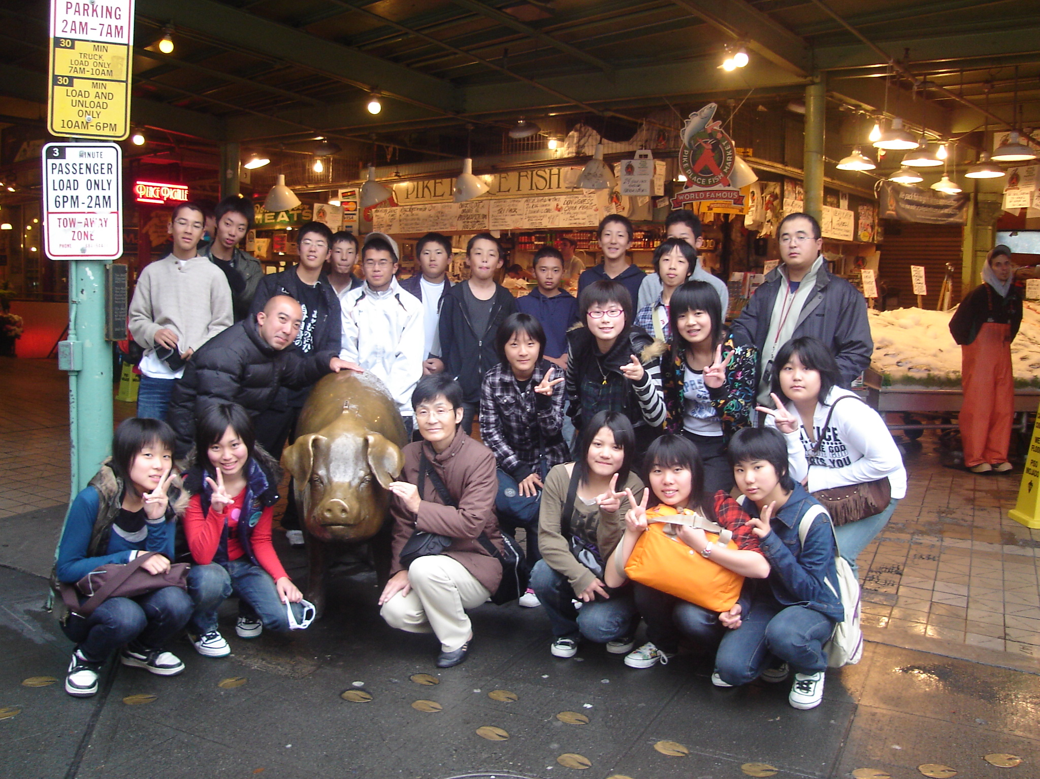

Seattle Education Tour Center
1511 3rd Ave. #1002
Seattle, Washington 98101
Phone: (206) 623-7060 Fax: (206) 623-9848
E-mail: seattle.edu@educationtourcenter.com

